# CS 255 System Design Document Template

## UML Diagrams

### UML Use Case Diagram

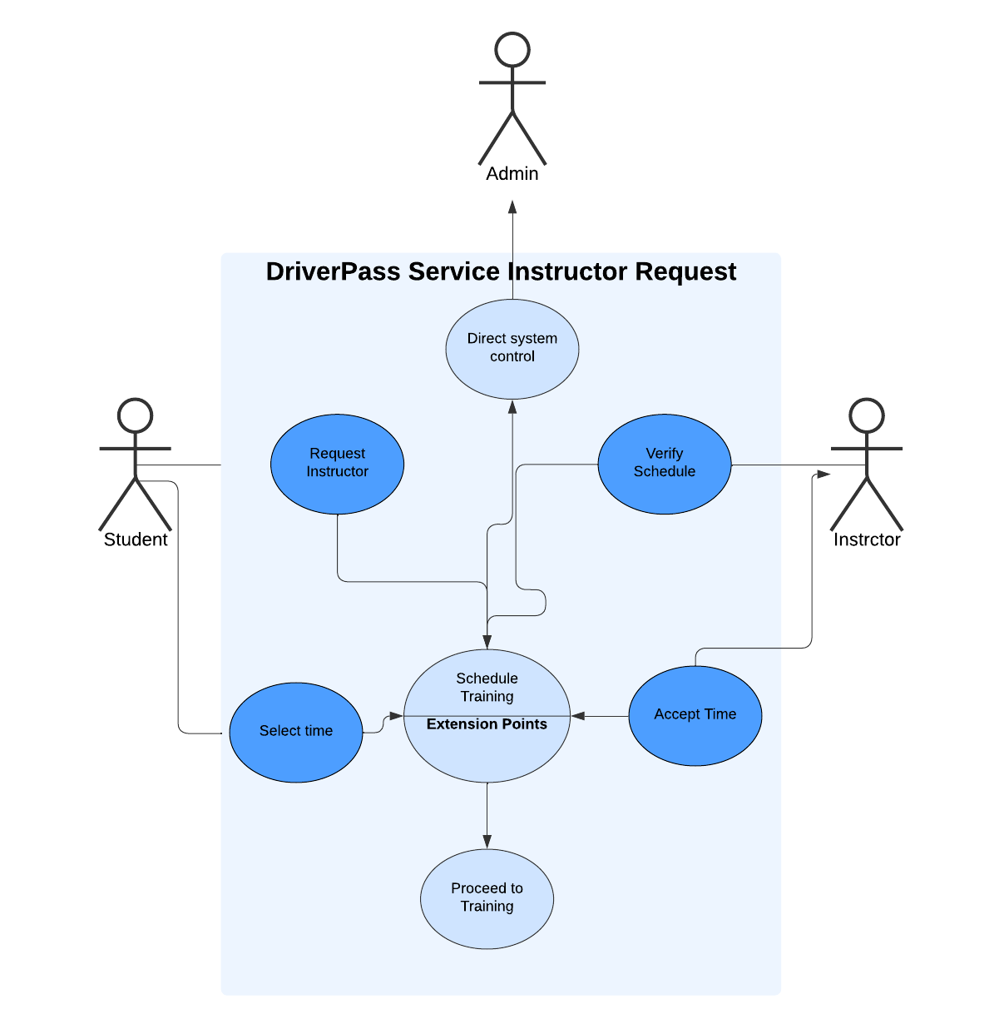

### UML Activity Diagrams

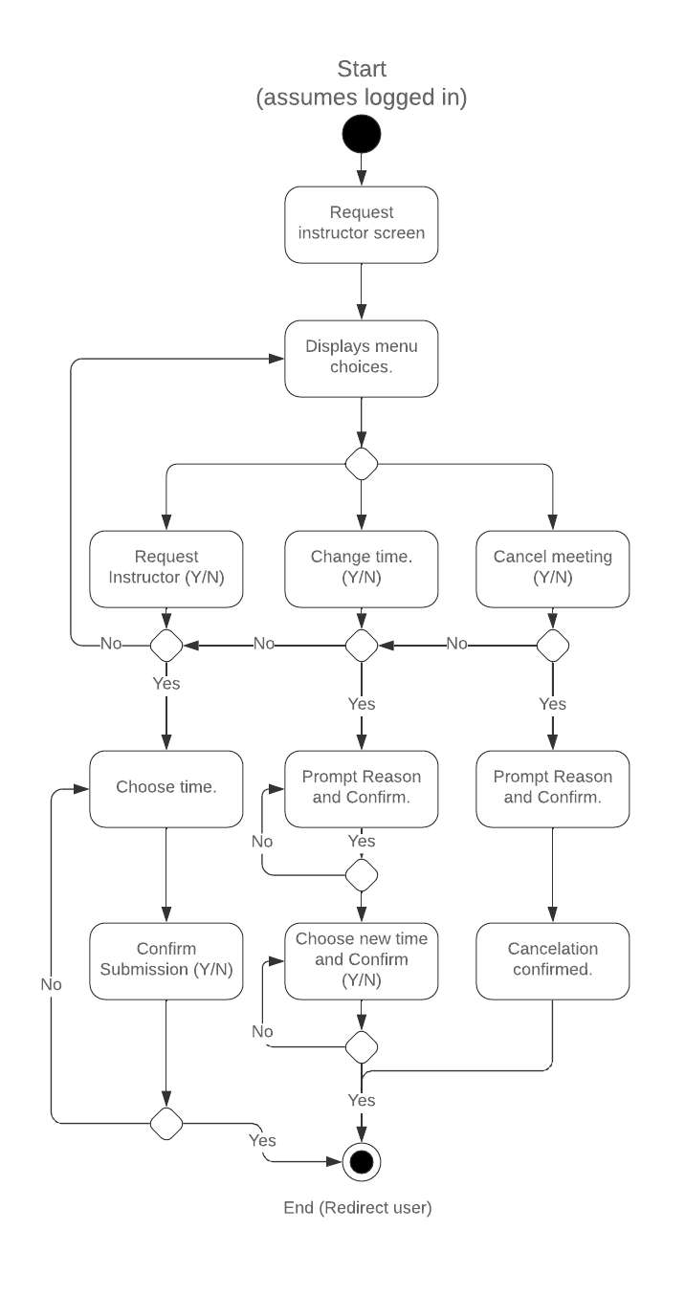

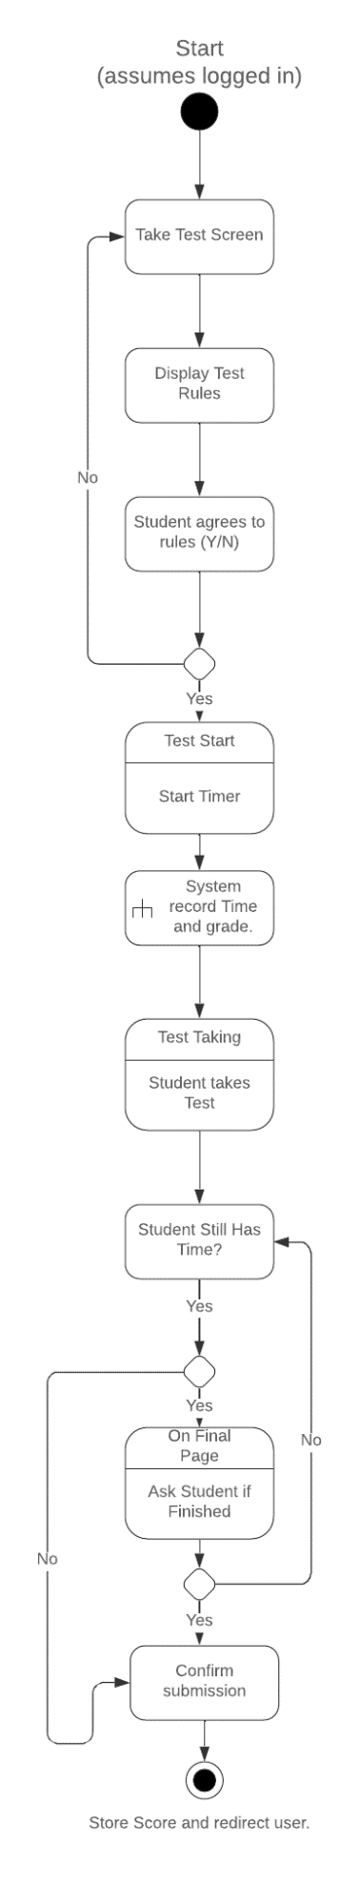

### UML Sequence Diagram

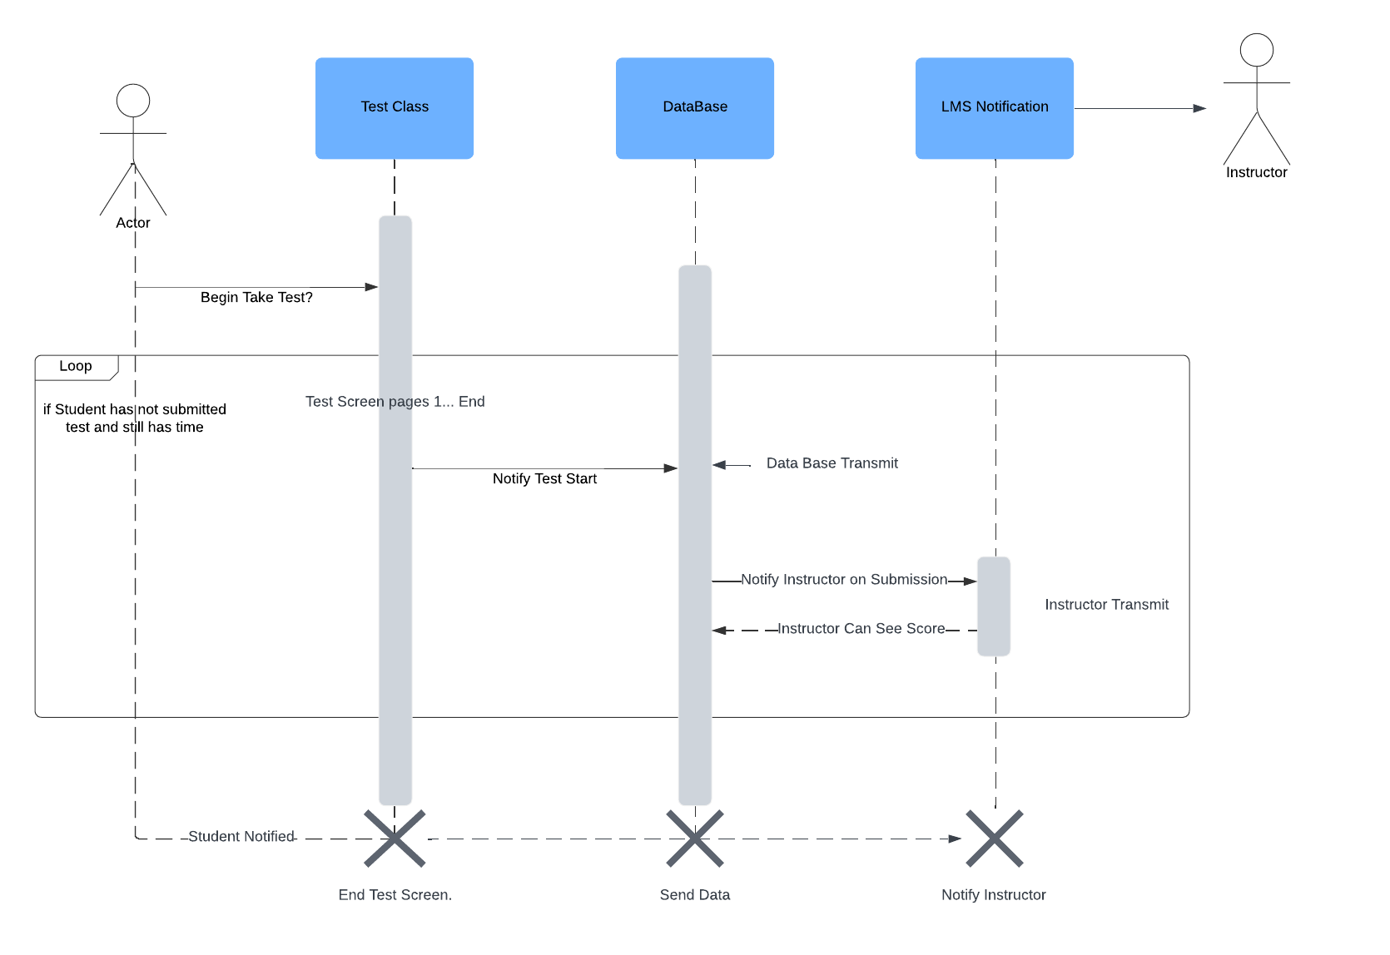

### UML Class Diagram

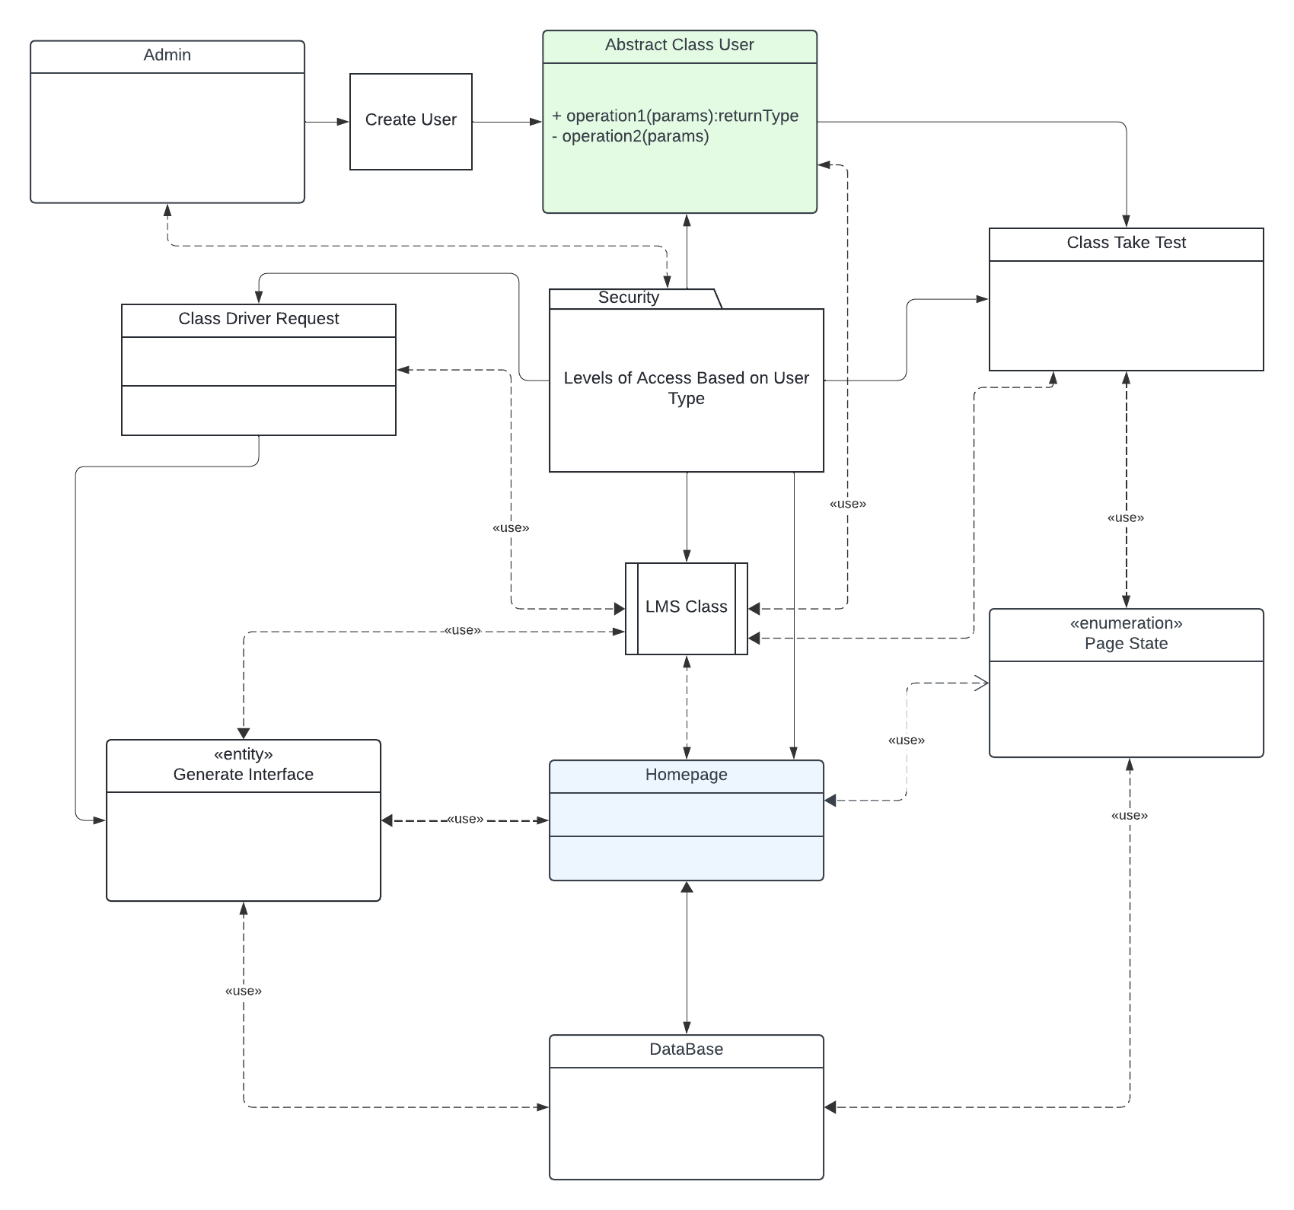

## Technical Requirements

The Technical Requirements are as such. Students should be able to take tests, request drivers and talk to instructors. The LMS class will handle communication between students and instructors, whether that is by email or updating grades. The LMS class will handle those types of processes. The admin shall have the ability to create new users and update security for each user. The admin will have full control over the system. The admin can create an IT officer user that can change and update other classes, such as the Test taking class for the student. The IT officer user can push any site updates or changes to the curriculum once it is approved. The student can use the test taking class to take the online test and use the request driver to schedule training. The instructor can post grades and notify students about them. All grades will be stored in the database as well as usernames and passwords. The homepage will server as the main page and the interface class will make use of page enumeration to generate the necessary UI for each page that the user sees.